**Arrays Practice Problems**

1. Write a program that does the following

a. Generates 10 Random 3 Digit number.

b. Store this random numbers into a array.

c. Then find the 2nd largest and the 2nd smallest element without sorting the array.

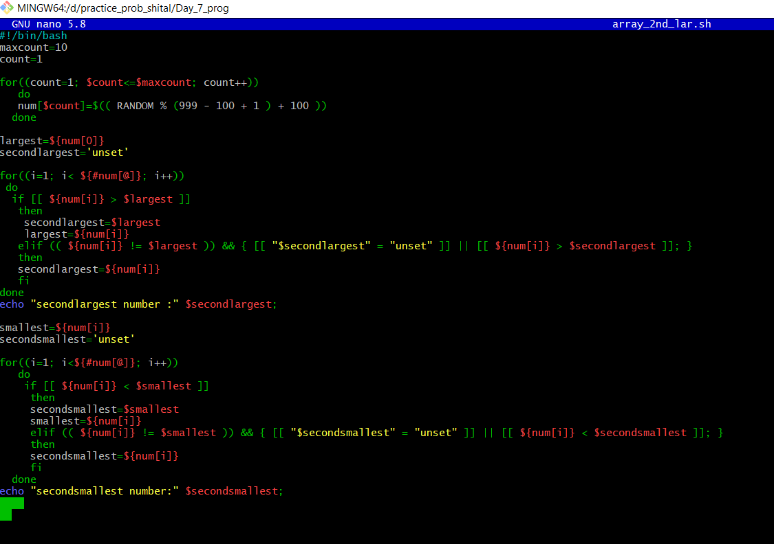

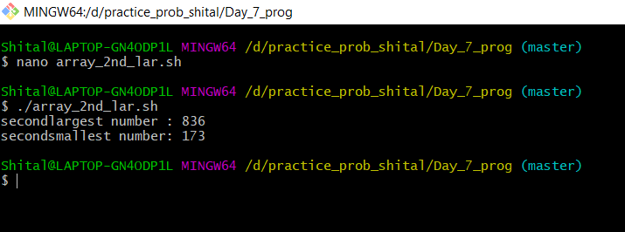

2. Extend the above program to sort the array and then find the 2nd largest and the 2nd smallest element.

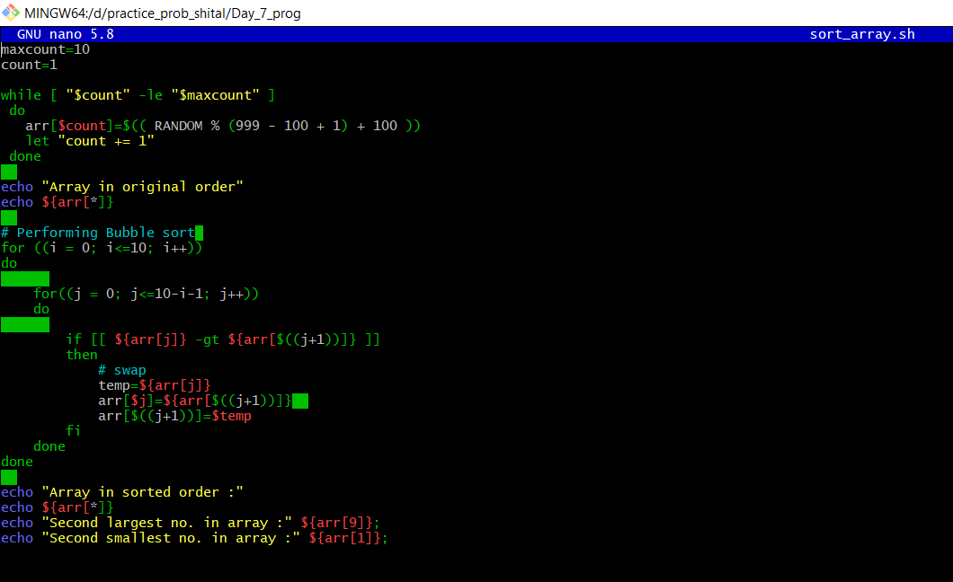

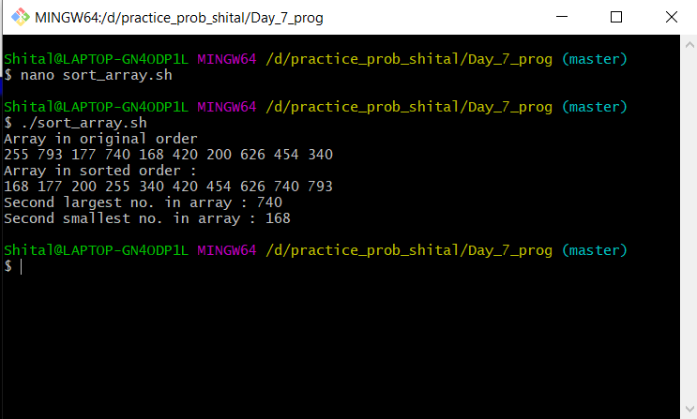

3. Extend the Prime Factorization Program to store all the Prime Factors of a number n into an array and finally display the output.

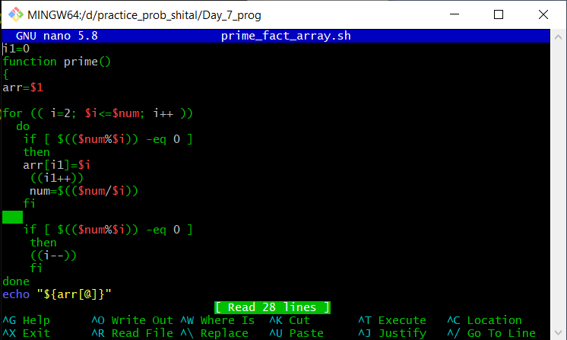

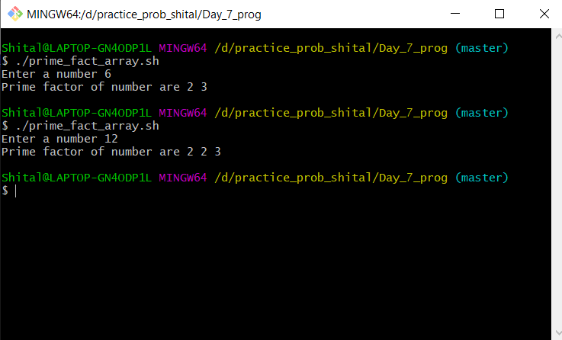

4. Write a Program to show Sum of three Integer adds to ZERO

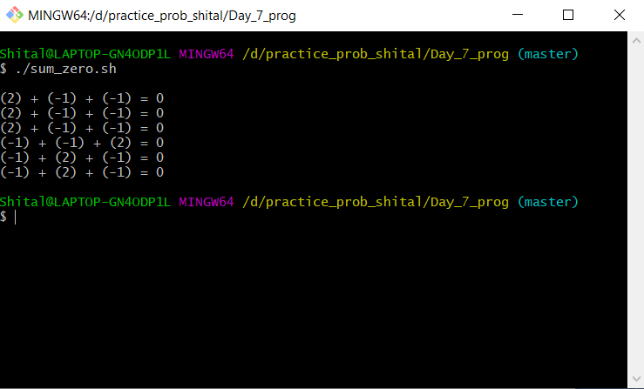

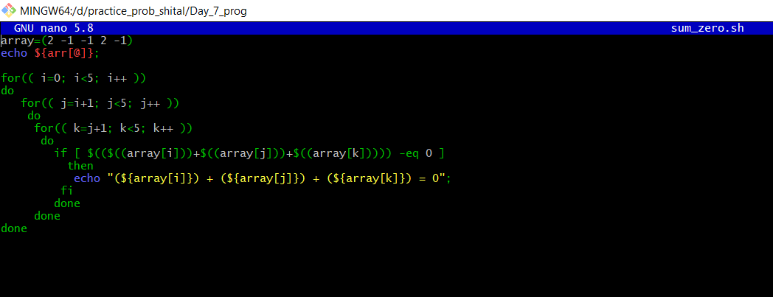

5. Take a range from 0 – 100, find the digits that are repeated twice like 33, 77, etc and store them in an array

